# How do you make decisions to solve problems?

1. Recognize the problem – the gap

In the first step, you need to recognize the gap between where you are now and where you want to be. At this point, you understand the situation and decide if it’s worth doing something. Is there a better way to do this?

When people don’t know what they’re looking for, they just see a bunch of stuff and assume all of it’s worth looking at. So, when you’re looking for a solution to a problem, start with an understanding of what that problem is. This will allow you better to identify the gaps. A problem is simply a discrepancy, a gap between the actual state of things and the desired state of things. It is the difference between where you are and where you want to be. You can define your problems as being too low on your sales quota or that you are having trouble getting enough traffic to your website. This is the beginning of a problem-solving process.

In this step, you can start with your vision of the desired state of your company and the goals you want to achieve. Here are some questions you need to answer as a part of this step in your decision-making process:

1. What are the most critical desired states for your small business?
2. How close is your small business to these states?
3. Why are you close or not close to the desired states?
4. What are the most significant problems here?

Example: Decrease in income as a problem

For example, if we analyze the company’s income, we can notice that this year’s income is 30% less than the previous year. That is a sign that something is going on and that a potential problem will require a solution.

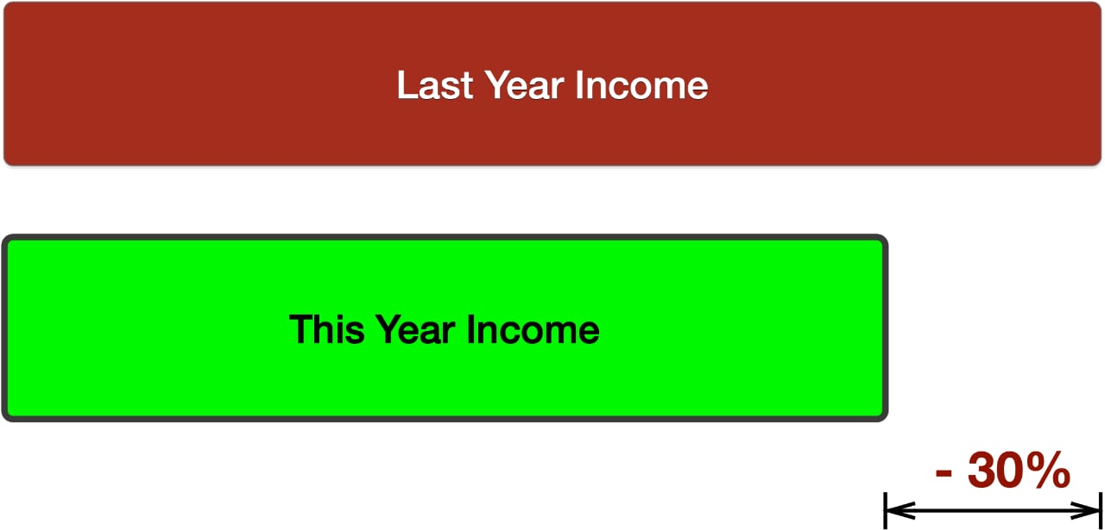

2. Collect All Relevant Information and Analyze the Problem

When you identify the problem, you need to collect all relevant information and analyze it as a part of the decision-making process. Ask yourself, “What is the next step in solving this problem? People tend to make decisions based on emotions such as anger, fear, or love rather than logic. So, emotions have a lot of influence over our behavior and decision-making. Once we get past the emotion, applying logic to decide the best course of action is easy.

You should always start with data. At the end of this step, you will need to have a list of possible problems sorted by their urgency for the solution. Also, you need to find the causes and how the problem impacts your small business in your analysis.

Example: Analyze why there is a decline in income

Let’s go back to our case with a 30% decrease in income. The analysis of the problem at this stage will represent an analysis of sales and marketing activities in the company by regions, employees, used techniques, etc. In this situation, you can find that the decrease in income is due to two regions with a 40-60% drop in income realization. Or the problem occurs only with specific employees in marketing or sales. Or it could be a combination of regions, employees, or marketing and sales techniques. These analyzes aim to prepare you for the next stage of the process.

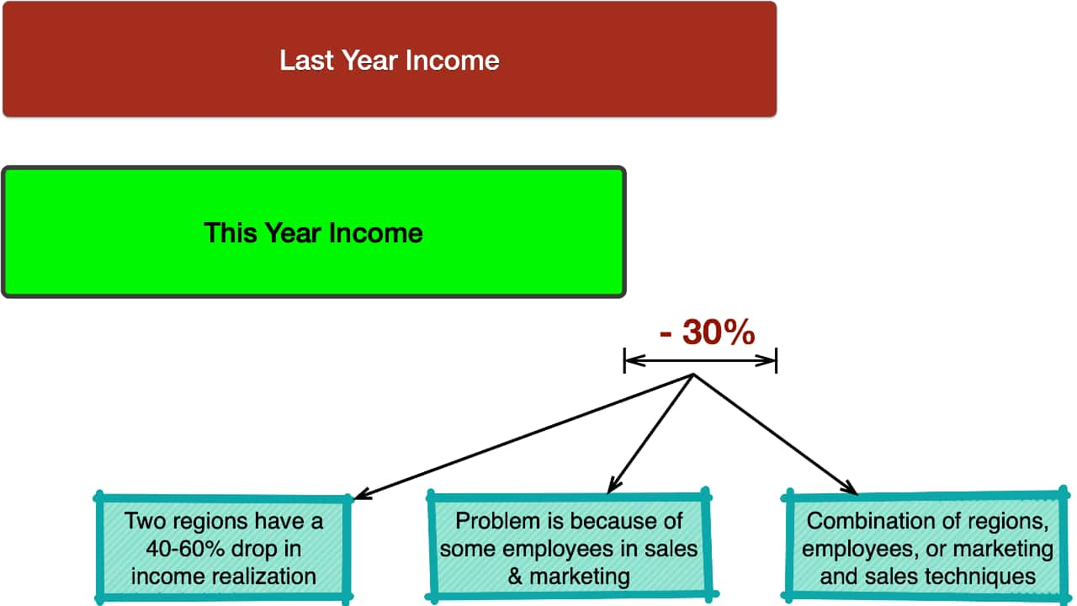

3. Define Alternative Solutions

After defining and analyzing the problem, you can move on to the next phase, which means defining alternative solutions.Based on the previous analysis’s conclusions, you can easily define alternative solutions to solve the detected and analyzed problem. Example: Alternative solutions to solve the decrease in income.If the previous step and analysis of the problem tell us that the source of the problem is decreased income in two regions, we can have alternative solutions such as:

1. conduct training of the sales and marketing team for those regions
2. strengthening marketing activities in those regions, and
3. a combination of training and marketing activities.

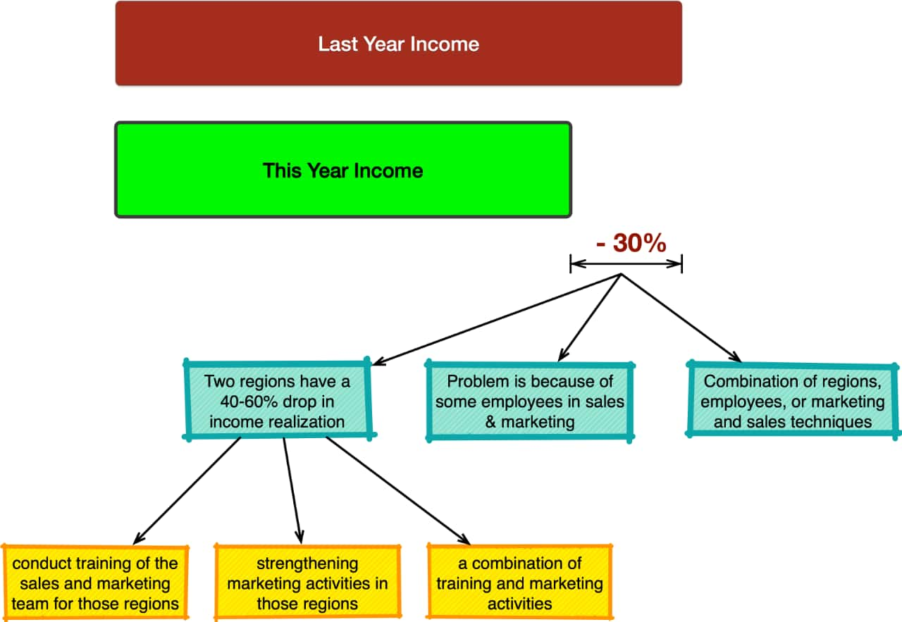

4. Analyze Alternative Solutions

Since each solution will bring different outcomes from the problem-solving process, you will need to analyze the solutions to determine the best one for implementation.

Simply, the question that arises is what you will achieve by implementing each of the alternative solutions. In this case, you can use modeling to model the implementation of each solution separately. In such a way, you will find the possible outcomes of all possible alternative solutions and the costs of their implementation. It’s crucial to analyze all the possible solutions to problems. You should be sure that your ideas and solutions are reasonable and workable. Use logical thinking when analyzing a problem.The decision matrix and decision tree are the most used tools in decision-making, especially for selecting the best possible alternative solution.

# Decision Matrix

When making decisions, you need to consider all the facts. Sometimes, the answer isn’t obvious, and you must choose between two or more options.A decision matrix can help you decide between two or more options. It’s easy to see the advantages and disadvantages of each alternative solution, as well as how well they fit into the overall picture. A decision matrix can be developed as a set of vectors that can help you determine the differences between different alternative solutions in terms the result of their implementation.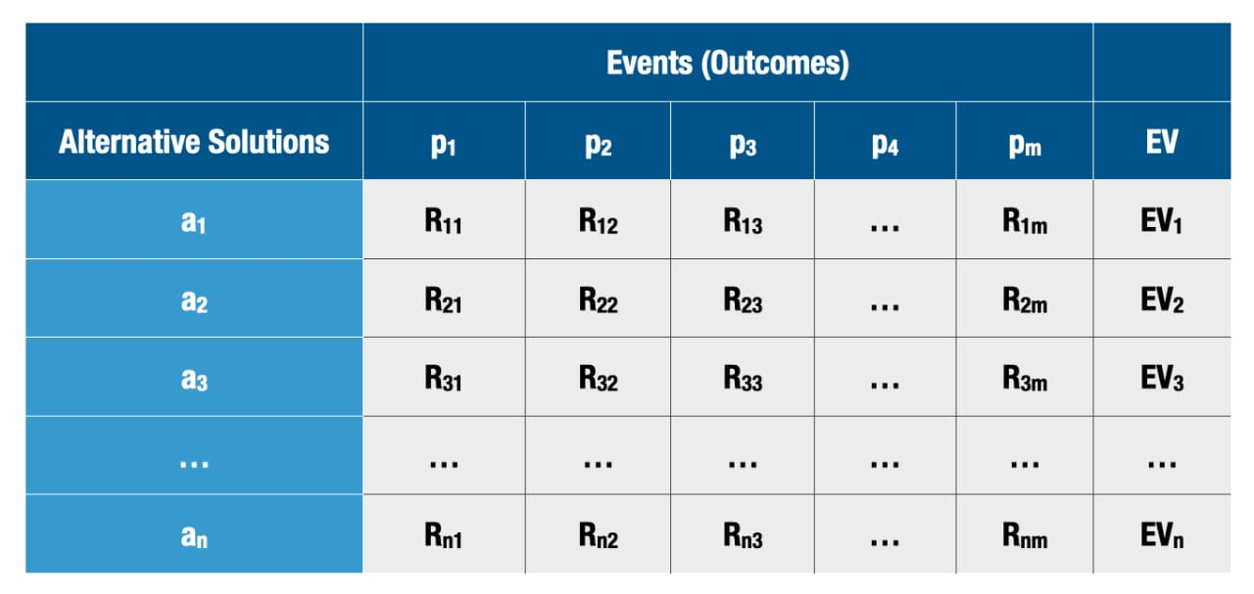

The decision matrix contains the following:

1. Alternatives available to the decision-maker ai where i = 1, 2, 3, … n.
2. Events that may occur and the occurrence of which will affect the outcome of each particular alternative. Each event has a probability of occurrence pj where j = 1, 2, 3, … m.
3. The outputs as the results of a combination of each alternative with each Rim event.
4. The payoff is a measure of the consequence like profit, income, or other expected value.

Using this matrix, for each combination of an alternative and possible event, you will know what will be the resulting payoff.

Each alternative has different outcomes. The most used approach in such cases of solving decision-making problems is called expected value – EV. Using the EV for each outcome about an alternative and a specific event defines the probability of occurrence of that specific event. So, the EV will be the total value of the results in any given row (alternative) in the decision matrix with the probability of each event. In such a way, we calculate the EV for each alternative solution and choose the alternative with the highest EV.

Eg: For example, you want to invest in developing a new product. If competition with the same product appears, the profit from that new product for the company will be $1.000.000 per year. If there is no competition, the profit will be $3.000.000 annually. The probability of the event that you will be without competition in the first year is 0.3, i.e., 30%. Should you invest in the development of that new product or not?

In this case, we have the following two alternatives:

1. to invest in the development of a new product
2. not investing in the development of a new product

We also have two events with their probability of occurrence:

1. there will be competition with a probability of 0.3
2. there will not be competition with a probability of 0.7.

But we also have payoffs for the company that is affected by the corresponding event:

* if there is competition, the profit will be $1.000.000.
* if there is no competition, the profit will be $3.000.000.

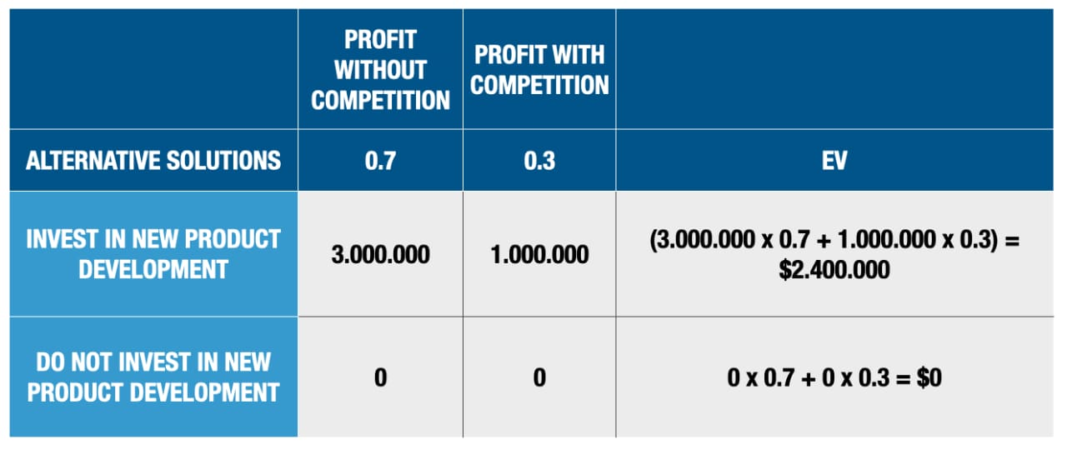

In this case, the first alternative, to invest in new product development, is a better solution.

Example 2: For example, if you want to invest in developing a new product, there are three types of products available. From the first product, you can earn $1.000.000, from the second $2.000.000 and from the third $1.500.000 with competition in the first year. Without competition, from the first product, you can earn $3.000.000, from the second $4.000.000 and from the third product $3.500.000. It is known that the probability of having competition for the first product is 0.3, for the second 0.4, and for the third 0, and the probability that there will not be competition for the first product is 0.7, for the second 0.6, and for the third 1. Here is the decision matrix for this example.

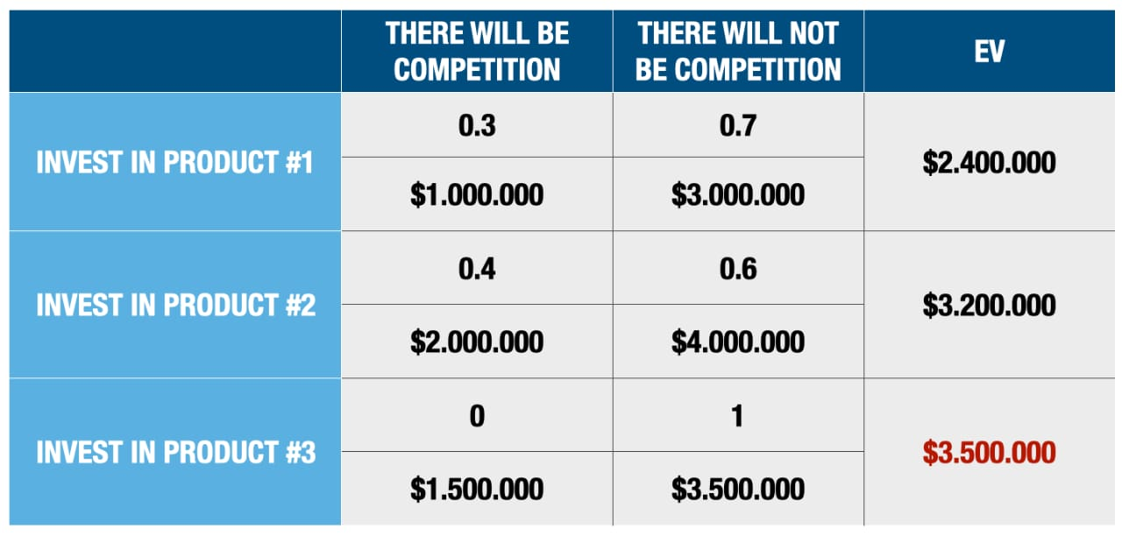

In this case, we will have at the beginning a decision on which product to invest, product 1, 2, or 3. Each of those possible decisions branches out further, setting the possible events and the probability that those events will happen.

* There will be competition with a probability of 30% (0.3)
* There will not be competition with a probability of 70%.

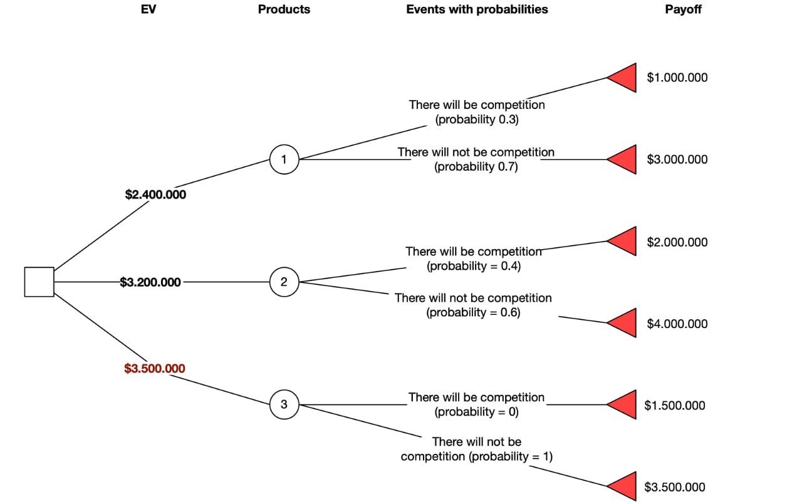

Each of those events brings a corresponding benefit or loss to the company. So, for the decision for the first product to have competition, the profit will be $1.000.000, while in the absence of competition, the profit will be $3.000.000. In the same way, we can continue with the second and third products.

5. Choose the Best Solution

The next step is to choose the best solution to your problem. Choose the one that will solve your problem best. Don’t be hasty with your decisions.

When you analyze the alternative solutions, you can rank them according to specific criteria that will provide the best conditions and results for the company. Selecting the alternative solution will almost always require an optimal solution. An optimal solution is the one that will give you the best results with the least effort and costs for the company. Simply, the results of the previous stage enable the ranking of the alternative solutions, with which the best solution, i.e., optimal, will be chosen.

6. Implement the decision

A critical aspect of the decision-making process is the implementation stage. After you have decided what to do, you need to do it. Don’t procrastinate. Don’t put off doing the job. Get it done, and then move on to another task.

But why do you need a decision if you don’t implement it? Every decision is made to be implemented. Implementing the decision will also mean solving the problem, i. e. , improving your small business.